NAME: K Yamini
REG NO: 192572181

Write a Prolog Program to implement Towers of Hanoi.
Aim:
To implement the Towers of Hanoi problem using recursion in Prolog.
Algorithm:
- Start the program.
- Take the number of disks N.
- Consider three rods:
Source
Auxiliary
Destination
- If there is only one disk, move it directly from Source to Destination.
- If there are more than one disk:
Move N-1 disks from Source to Auxiliary.
Move the largest disk from Source to Destination.
Move N-1 disks from Auxiliary to Destination.
- Repeat the steps recursively until all disks are moved.
- Display each move.
- Stop the program.
Prolog program:
% EXPERIMENT 21
% Towers of Hanoi

% Base case: Move one disk
hanoi(1, Source, Destination, _) :-
write('Move disk from '),
write(Source),
write(' to '),
write(Destination),
nl.

% Recursive case
hanoi(N, Source, Destination, Auxiliary) :-
N > 1,
N1 is N - 1,

% Move N-1 disks from Source to Auxiliary
hanoi(N1, Source, Auxiliary, Destination),

% Move the largest disk to Destination
write('Move disk from '),
write(Source),
write(' to '),
write(Destination),
nl,

% Move N-1 disks from Auxiliary to Destination
hanoi(N1, Auxiliary, Destination, Source).
Input:
?- hanoi(3, source, destination, auxiliary).
Output :
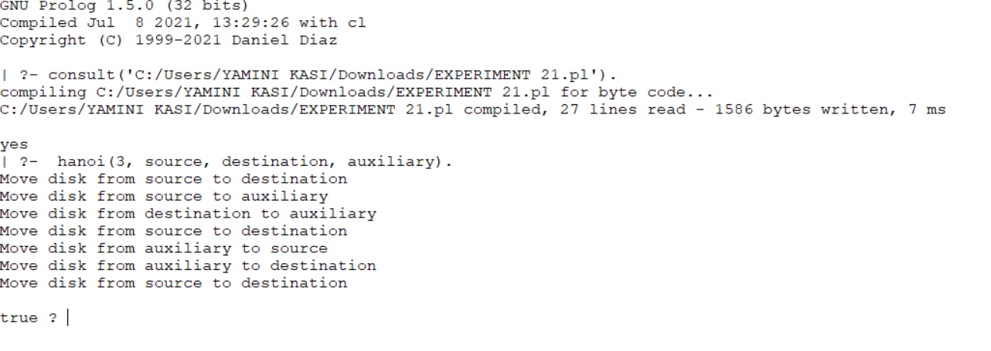

Result:
Thus, the Towers of Hanoi problem was successfully implemented in Prolog using recursion, and all disk movements were obtained correctly.

